2024

Creating PPC ads using google ads

With step-by-step procedure

Hareesh R, Jayaselvi S, Manisankar M, Manigandan S

UCE (BIT Campus), Anna University, trichy



A project documentation on

Creating Effective PPC Ads Using Google Ads Submitted in the partial fulfillment of requirements for the certificate of completion of the **digital marketing course given under Naan Mudhalvan Scheme by**

**Govt of Tamil Nadu**

By

|  |  |
| --- | --- |
| **Student name** | **Register number** |
| Hareesh R | 810020106026 |
| Jayaselvi S | 810020106033 |
| Manigandan S | 810020106049 |
| Manisankar M | 810020106050 |

**Final year**

**Department of**

**Electronics and Communication Engineering**

**University College of Engineering (BIT Campus)**

**Anna university, Trichy**

**2023-2024**

Abstract:

Pay-Per-Click (PPC) advertising through Google Ads is a powerful tool for businesses to reach their target audience and drive relevant traffic to their websites. This project aims to provide a comprehensive guide on creating and optimizing PPC ads using Google Ads to maximize your advertising investment. The project begins by outlining the fundamentals of PPC advertising, explaining the auction-based model of Google Ads, and demonstrating how keywords and ad placements play a pivotal role in campaign success. It then delves into the practical steps to set up and manage a Google Ads campaign, from account creation to selecting the right campaign type and targeting options. The heart of the project focuses on ad creation. It covers the principles of writing compelling ad copy, designing attention-grabbing visual ads. The project also emphasizes the importance of monitoring and adjusting campaigns regularly to improve ad performance and achieve desired results.

Introduction:

Marketing has always been a critical component of business success, serving as a bridge between companies and their target audiences. Over the past few decades, marketing has undergone a significant transformation, moving away from traditional methods and rapidly embracing digital channels. This shift, often referred to as the "Digital Marketing Revolution," has revolutionized the way businesses promote their products and interact with their customers.

Digital marketing

Digital marketing has revolutionized the way businesses and organizations promote their products, services, and messages in the modern age. It's a comprehensive and dynamic field that leverages digital channels, technology, and data to connect with the target audience, build brand presence, and drive measurable results. This introduction will provide you with an overview of the fundamental concepts of digital marketing.

Key Components of Digital Marketing:

1.Online Presence: At the core of digital marketing is establishing a strong online presence. This includes having a website and profiles on social media platforms. Your website serves as the digital storefront where potential customers can learn about your offerings.

2. Content Marketing: Content is king in the digital world. Creating valuable and relevant content such as blog posts, articles, videos, and infographics not only educates and engages your audience but also improves your website's search engine visibility.

3. Search Engine Optimization (SEO): SEO is the practice of optimizing your website to rank higher in search engine results pages (SERPs). By using relevant keywords and improving your site's structure, you can increase organic (non-paid) traffic.

4. Social Media Marketing: Leveraging platforms like Facebook, Twitter, Instagram, and LinkedIn, social media marketing allows you to interact with your audience, share content, and run targeted advertising campaigns.

5. Email Marketing: Email marketing is an effective way to nurture leads, engage with customers, and promote products or services directly to a subscriber list.

6. Pay-Per-Click (PPC) Advertising: PPC advertising is a model where advertisers pay a fee each time their ad is clicked. It's often used in search engine marketing and social media advertising to drive traffic and conversions.

7. Online Advertising: This includes display ads, video ads, and other forms of advertising on various online platforms.

8. Affiliate Marketing: Businesses partner with affiliates who promote their products or services, and in return, they earn a commission for each sale or lead generated.

9. Analytics and Data Analysis: Digital marketing relies heavily on data. Tools like Google Analytics provide insights into website traffic, visitor behavior, and campaign performance, enabling data-driven decision-making.

10. Mobile Marketing: As more users access the internet through mobile devices, mobile marketing focuses on optimizing content and ads for mobile users.

Benefits of Digital Marketing:

1. Global Reach: Digital marketing allows businesses to reach a global audience, breaking down geographical barriers.

2. Cost-Effective: Many digital marketing strategies are cost-effective compared to traditional advertising methods.

3. Targeted Advertising: Digital marketing provides precise targeting options, ensuring your message reaches the right audience.

4. Measurable Results: It's easy to track and measure the performance of digital marketing campaigns, allowing for adjustments and improvements.

5. Interactivity: Digital marketing encourages two-way communication with customers, fostering engagement and brand loyalty.

6. RealTime Engagement: Businesses can engage with their audience in real-time, addressing concerns and inquiries promptly.

7. Flexibility: Digital marketing campaigns can be adjusted quickly in response to changing market conditions.

Pay per click advertisement

In the ever-evolving landscape of digital marketing, Pay-Per-Click (PPC) advertising has emerged as a powerful and highly effective strategy for businesses looking to connect with their target audience, drive traffic to their websites, and achieve specific marketing objectives. At its core, PPC is a model of online advertising where advertisers pay a fee each time one of their ads is clicked by a user. These ads can appear on search engines, social media platforms, and websites, offering a versatile means of reaching potential customers.

PPC advertising stands as a pillar within the broader realm of digital marketing, and it offers unique advantages, making it an essential tool for businesses of all sizes. It complements other digital marketing strategies such as search engine optimization (SEO), content marketing, and social media marketing by providing an immediate and measurable way to attract online visitors and generate conversions.

Key components and benefits:

1. Keywords and Ad Placement:

PPC advertising hinges on keywords and ad placement. Advertisers select specific keywords or phrases relevant to their products or services. When users search for these keywords, the ads appear, offering a potential solution to their queries.

2. Ad Auctions:

In platforms like Google Ads, PPC ads engage in auctions to determine their visibility. The auction considers factors like bid amounts, ad quality, and expected click-through rates. This competitive environment ensures that ads are relevant to users' interests.

3. Ad Creativity:

Crafting compelling ad copy is an art and science. Effective ad copy should be relevant, concise, and enticing, encouraging users to click. Visual elements, such as images and videos, also play a vital role in engaging audiences.

4. Measurement and Data:

One of the most significant advantages of PPC advertising is the ability to measure its effectiveness with precision. Advertisers can track metrics like Click-Through Rate (CTR), conversion rates, and return on investment (ROI), allowing for data-driven optimization.

5. Targeting:

PPC advertising empowers businesses to target specific demographics, geographic locations, and user behaviors, ensuring that their ads reach the right audience at the right time.

6. Immediate Results:

Unlike some digital marketing strategies that take time to yield results, PPC advertising offers almost immediate visibility and traffic to websites. It is particularly effective for time-sensitive campaigns.

7. Cost Control:

Advertisers have complete control over their budgets. They can set daily or monthly spending limits, ensuring that they stay within their financial constraints.

8. Continuous Optimization:

Ongoing optimization is essential for PPC success. Regularly testing and refining ad copy, keywords, and targeting parameters allows businesses to improve ad performance over time.

Project implementation:

Let us implement a PPC ad for our brand

Brand name: Tirupathy punganur dairy farm.

Brand logo:



Category: Milk and Dairy products

Email: [tirupathypunganur23@gmail.com](mailto:tirupathypunganur23@gmail.com)

Target Audience: for all dairy lovers

Target Location: Chennai-Tamil Nadu, Tirupathy, Chittoor-Andhra Pradhesh India

Step 1: Account Setup

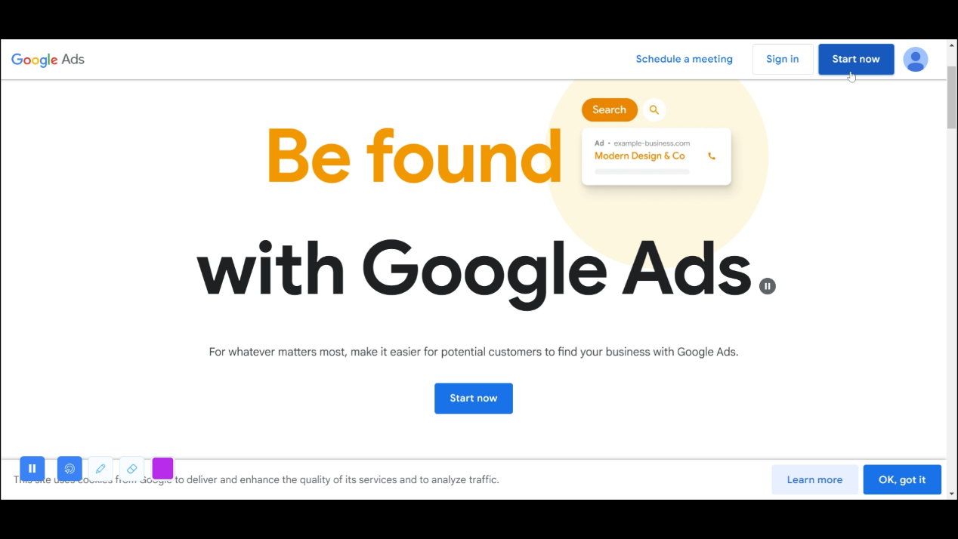1.1. Sign In or Create an Account

Go to the Google Ads website (https://ads.google.com) and sign in with your Google account. If you don't have an account, create one. Click the ‘Start now’ button at the top right corner of the window.

Step 2: Enter business details

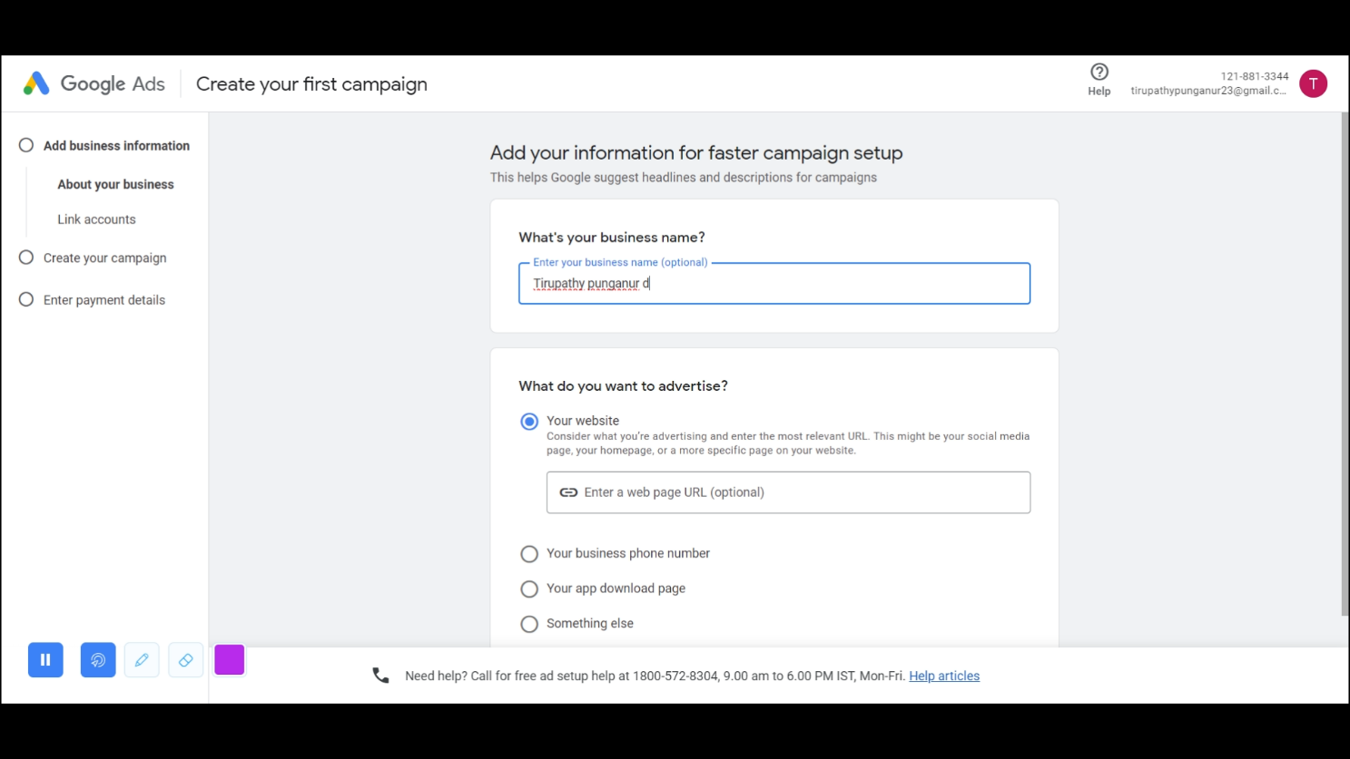

Step 3: Choose the goal of the campaign

Step 4: Ad Creation

4.2. Ad Content

Write compelling ad copy with a clear call-to-action (CTA).

Include relevant keywords in the ad text to improve ad relevance.

4.3. URLs

Add the final URL (the landing page where users will be directed) and display URL (the visible URL).

We added our Facebook business page URL, Which contains all required business details.

*https://www.facebook.com/profile.php?id=61550599855410&mibextid=ZbWKwL*

4.4. Add images of your business site as well as relevant stock images (at least 2 Nos). You can add upto 20 images.

4.5 Add business logo (at least 2 Nos). You can add up to 5 logos

4.6. You can also add short videos if necessary.

4.7. Headlines.

Headlines are short link texts which appear in large text in your google ad. We can add texts upto size 30 characters.

Here we added four headlines for our brand

4.8. Long headlines

Long headlines serve the same process as of above-named headlines but we can add more details about 60 characters.

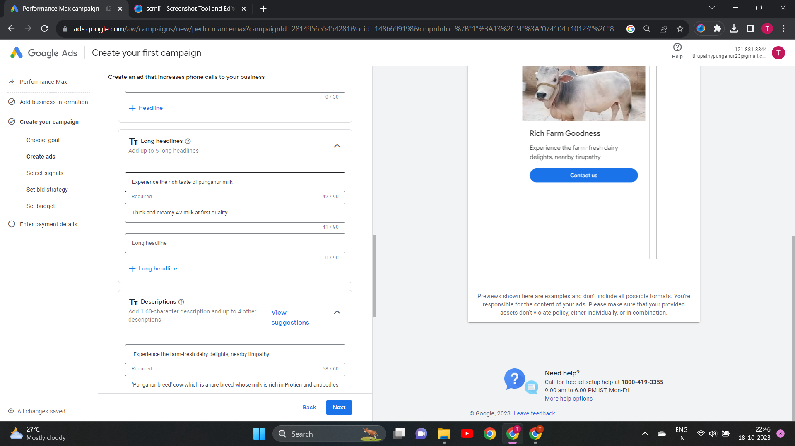Here we added two long headlines

4.9. Description

We can add short and long descriptions. Short descriptions should be within size 60 characters and for long headlines the size is 90 characters.

Step 5: Ad Preview and Testing

5.1. Ad Preview

Review the ad using the ad preview tool to see how it will appear in search results.

We can view the ads in

* Ads in android mail
* Ads in desktop mail
* search result page in android
* search the result page in desktop

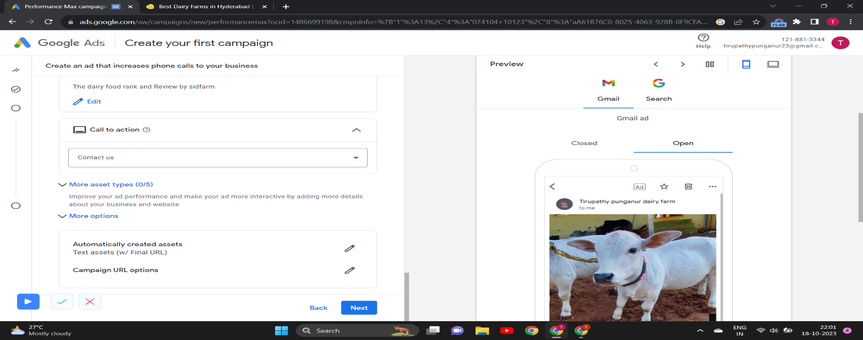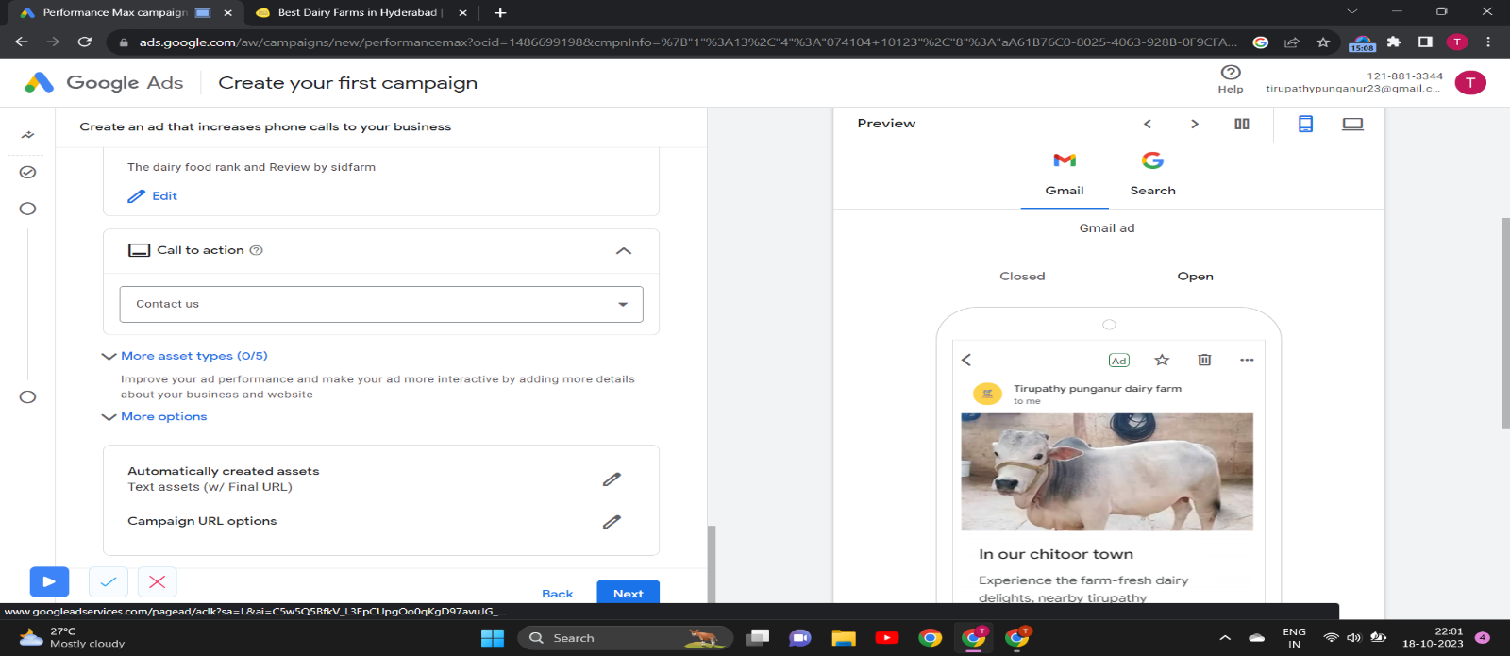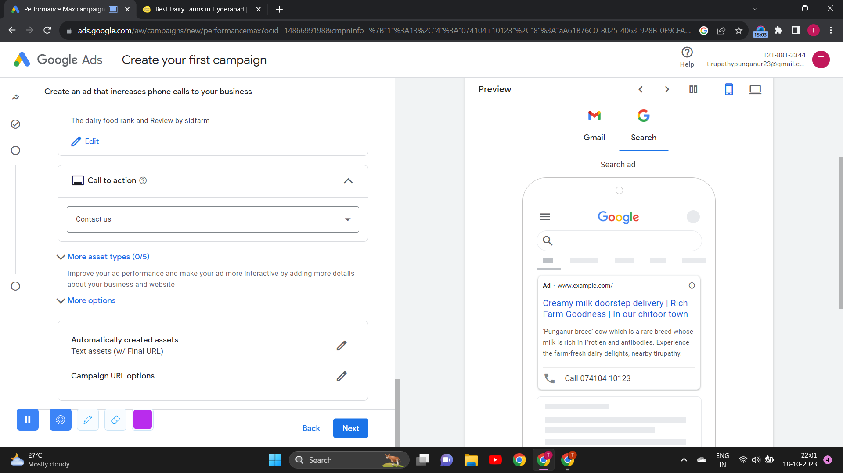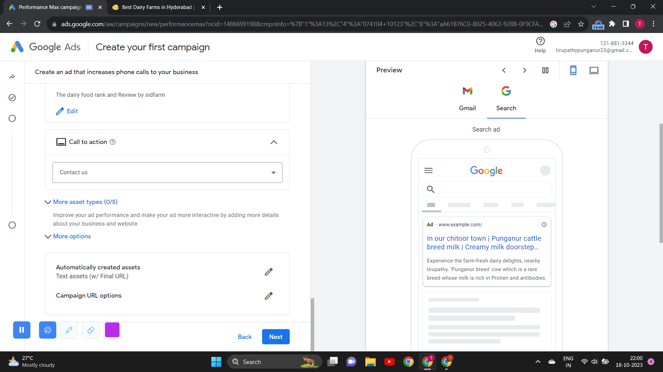

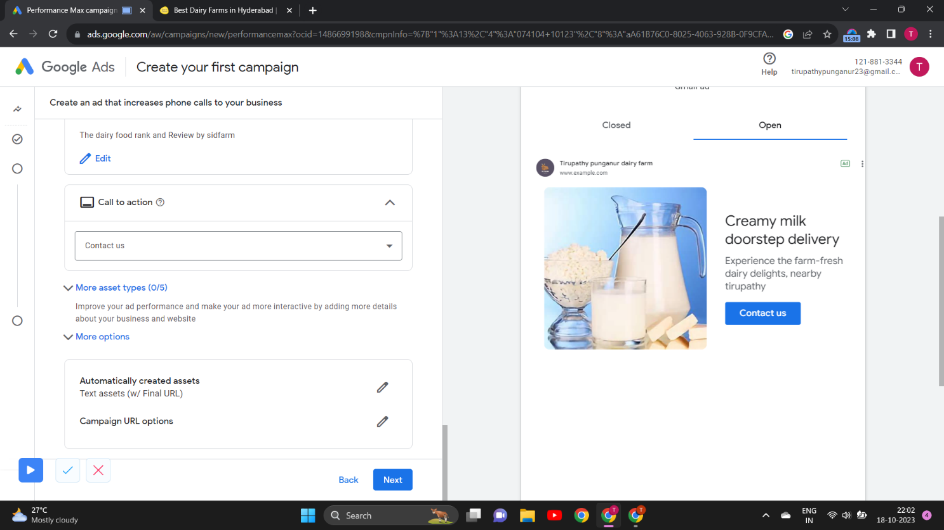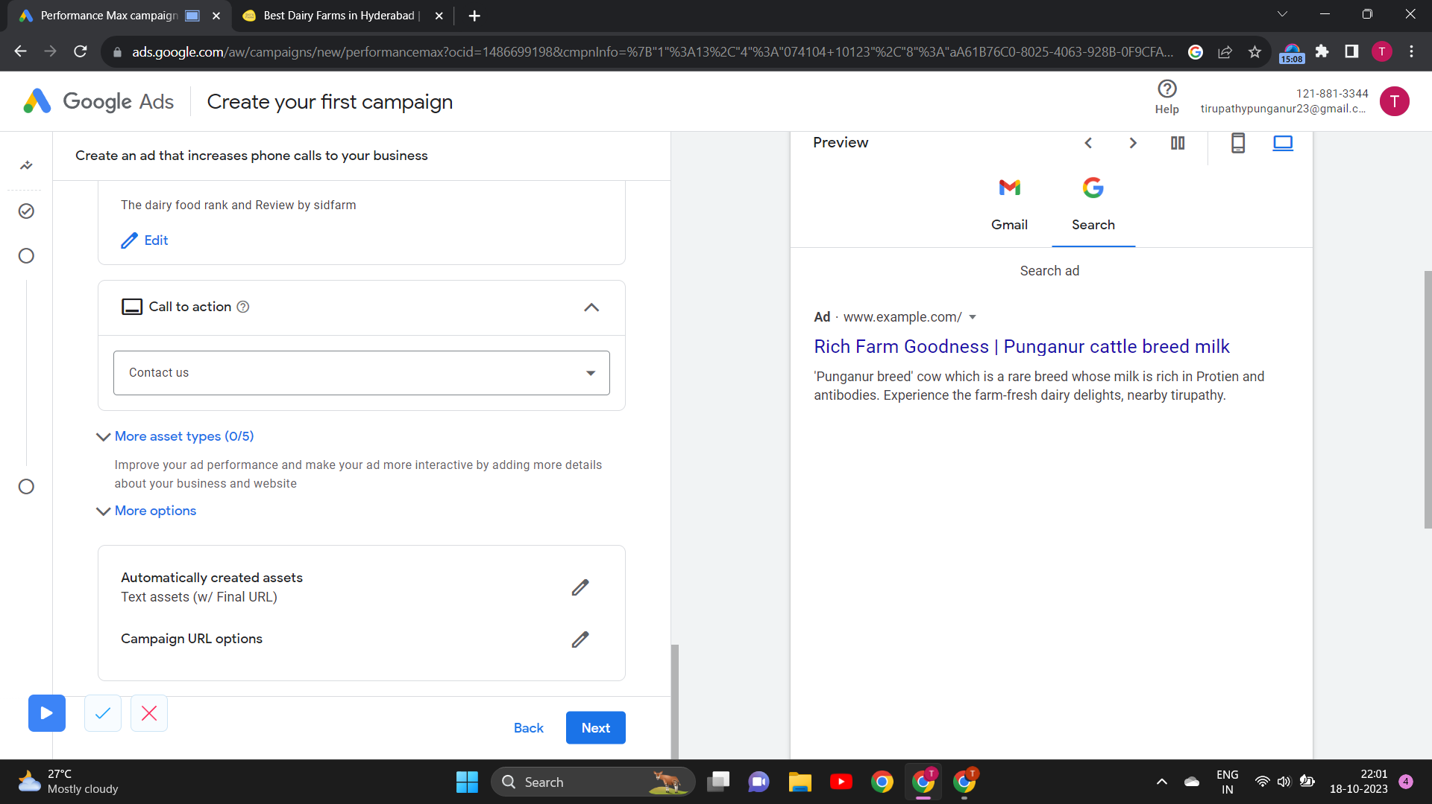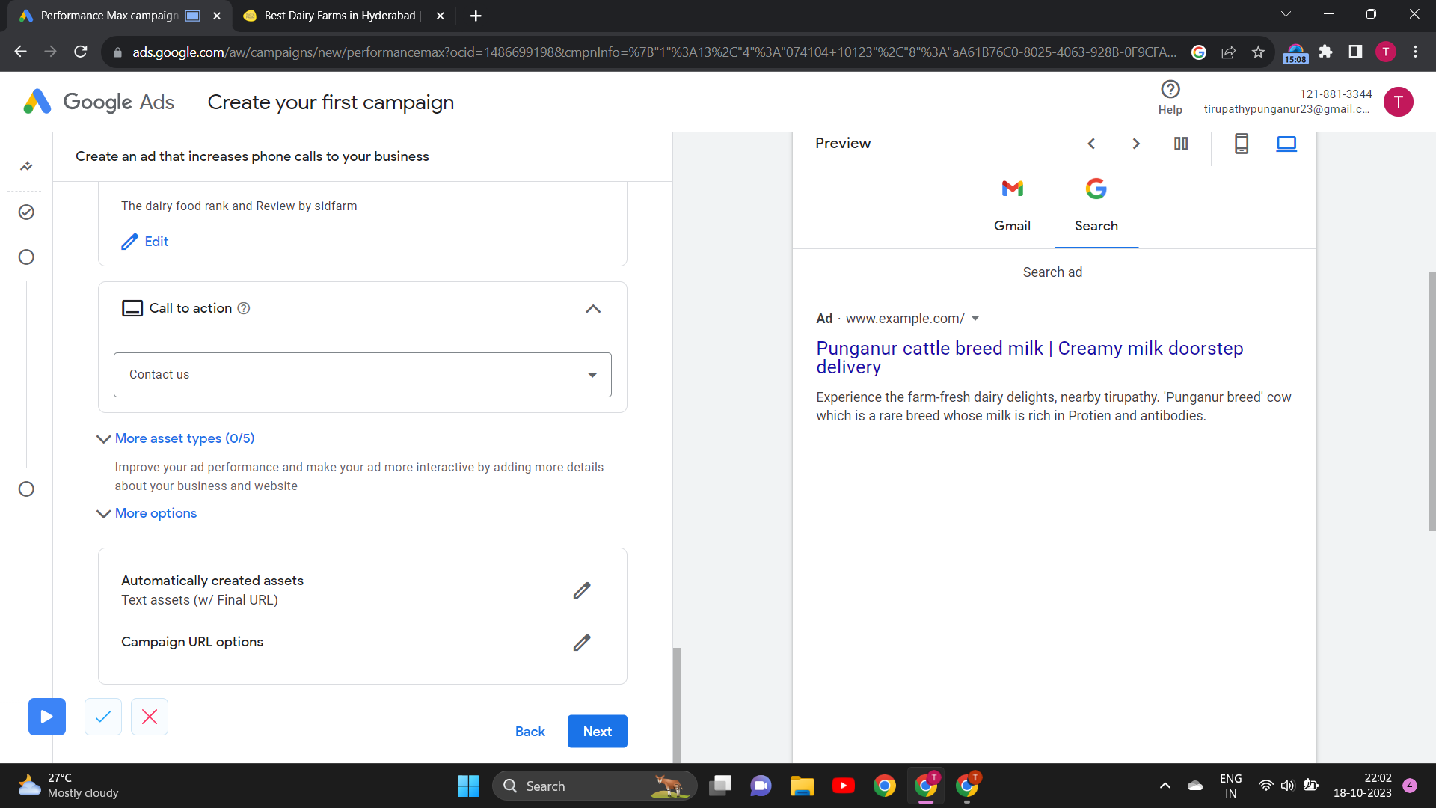

6.1. Keyword Selection

Add the relevant keywords to your ad group, using a mix of broad, phrase, and exact match types of your business. You can add up to 10 keywords.

6.2. Audience and Location Targeting

Define your target audience and geographic locations for better ad relevance.

Since we have our brand Chittoor town based, we added locations. They are Chittoor and Tirupathy towns in Andhra Pradesh and Chennai.

And also, we added Tamil and Telugu regional people as audience

Step 7: Bid Strategy

7.1. Bidding

Choose a bidding strategy, such as Manual CPC, Target CPA, or Maximize Conversions, to control how you want to bid for clicks.

Bidding strategies in Google Ads are methods used by advertisers to determine how much they are willing to pay for each click on their ads. These strategies are designed to optimize campaign performance and achieve specific goals. Here are a few common bidding strategies:

Manual CPC (Cost-Per-Click): Advertisers manually set the maximum amount they are willing to pay for each click. This strategy provides full control but requires ongoing monitoring and adjustments.

Enhanced CPC: This strategy allows Google to automatically adjust bids based on the likelihood of conversion. It increases bids for clicks with a higher potential to convert and decreases bids for less promising clicks.

Target CPA (Cost-Per-Acquisition): Advertisers set a target cost-per-acquisition, and Google's algorithm adjusts bids to meet that goal, optimizing for conversions.

Target ROAS (Return on Ad Spend): Advertisers specify the desired return on ad spend, and Google's algorithm adjusts bids to maximize the return, optimizing for revenue.

Maximize Clicks: This strategy aims to get as many clicks as possible within a specified budget. Bids are automatically adjusted to achieve the highest possible click volume.

Maximize Conversions: Google's algorithm automatically adjusts bids to get the most conversions possible within your budget.

Target Impression Share: Advertisers set a target impression share (the percentage of times their ad appears when eligible). Google adjusts bids to achieve this goal.

Manual CPM (Cost-Per-Thousand Impressions): This strategy is used for display and video campaigns where advertisers pay for every 1,000 ad impressions. Advertisers set the maximum CPM bid.

Portfolio Bidding: Advertisers group multiple campaigns together and set a target for a specific portfolio-wide metric, like a target CPA across all campaigns.

Each bidding strategy serves different advertising objectives and suits different campaign types. Choosing the right strategy depends on your goals, budget, and the type of ads you are running. It's important to regularly monitor and adjust your bidding strategy to optimize your campaign's performance.

In our campaign it was applied maximum conversions biding which is the default bidding strategy.

8. Billing Information

Provide billing information to set up your payment method. You can choose from various payment options, including credit card or bank account

Step 9: Review and Launch

9.1. Review

Carefully review all settings, ad content, targeting, and budget.

9.2. Launch Campaign

Click the "Save" or "Publish" button to launch your campaign.

Step 10: Monitoring and Optimization

10.1. Monitoring

Regularly check the performance of your ads, keywords, and campaigns in the Google Ads dashboard.

10.2. Optimization

Make data-driven optimizations, including adjusting bids, pausing underperforming keywords, and creating new ad variations.

Conclusion:

This project serves as a valuable resource for both beginners and experienced advertisers looking to harness the potential of Google Ads for PPC advertising. It provides a step-by-step guide to create and optimize PPC ads effectively, ensuring businesses can reach the right audience, increase brand visibility, and drive meaningful conversions.